**Court & Fingerprint Date Calculator Guide**

**Overview**

The Court & Fingerprint Date Calculator is a web-based tool that helps determine court appearance dates and corresponding fingerprint appointment scheduling based on jurisdiction-specific rules and squad assignments. This guide provides step-by-step instructions for accessing and using the calculator.

**Accessing the Calculator**

The Court Calculator has been bookmarked on all workstations in Chrome.

1. Open Chrome and locate the 'Court Calculator' in the bookmark bar at the top of the browser.
2. Click the bookmark to open the calculator.

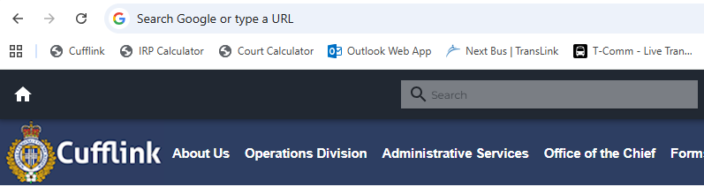

**Using the Calculator**

**Step 1: Review Important Notes**

Before entering any information, review any important notes displayed at the top of the calculator interface. These may contain current updates, known issues, or special instructions.

**[Screenshot placeholder: Calculator interface showing important notes section]**

**Step 2: Choose Court City**

Select the appropriate court city from the dropdown menu. Available options include:

* Vancouver
* Burnaby
* Richmond
* Surrey (Including Delta, Langley & White Rock)
* New Westminster
* Coquitlam (Including Port Coquitlam, Port Moody, Pitt Meadows & Maple Ridge)
* North Vancouver (Including West Vancouver)

**[Screenshot placeholder: City dropdown menu]**

**Step 3: Choose Case Type**

Select either "Adult" or "Youth" from the Case Type dropdown menu.

**Step 4: Enter First Letter of Surname (If Required)**

**Note:** This field is only required for certain cities and case types. The field will be disabled when not needed.

When required, enter the **FIRST letter only** of the surname.

* Example: Enter 'S' for Smith
* Example: Enter 'J' for Johnson

**[Screenshot placeholder: Initial field with example]**

**Step 5: Enter Number of Weeks Out**

Enter the number of weeks from today for the desired court date. The default value is 6 weeks, which covers most standard scheduling needs.

**Step 6: Select Issuing Squad**

Choose the squad that is requesting the court dates from the dropdown:

* A Squad
* B Squad
* C Squad
* D Squad

**Example:** If C Squad is asking for court dates, select "C Squad"

**[Screenshot placeholder: Full form with all fields completed]**

**Step 7: Calculate Dates**

Click the "Calculate Dates" button to generate the court and fingerprint dates.

**Step 8: Review Generated Results**

The calculator will display:

* **Court Information:** Date, time, and address
* **Fingerprint Information:** Date, time, and location
* **Copy/Paste Format:** Pre-formatted text for easy entry into CAD systems

**[Screenshot placeholder: Results display showing court and fingerprint information]**

**Step 9: Copy Results to CAD**

1. Click the "Copy to Clipboard" button in the Copy/Paste Format section
2. Navigate to your CAD system typing area
3. Right-click and choose "Paste" or use the keyboard shortcut **Ctrl+V**
4. **Important:** Add 'AR' or 'ARN' to the beginning of the pasted text as required by your system

**[Screenshot placeholder: Copy to clipboard section]**

**Step 10: Reset Calculator (If Needed)**

To reset the calculator for new calculations:

* **Method 1:** Refresh the page by re-clicking the 'Court Calculator' bookmark
* **Method 2:** Simply change/edit the fillable areas and re-click 'Calculate Dates'

**Additional Information**

**Validation and Testing**

**Important:** Although comprehensive testing has been completed, it is recommended to use the calculator in conjunction with manual verification methods for the first few weeks to ensure accuracy. Please verify:

* Fingerprint dates and times are accurate for each squad
* Correct court dates are chosen for Richmond's rotating calendar
* Court days align with jurisdiction-specific rules

**Troubleshooting and Bug Reports**

If you encounter any mistakes, bugs, or unexpected results, please send an email with the following information:

1. **What you were attempting to calculate** (city, case type, surname letter, weeks out, squad)
2. **The results the calculator produced**
3. **What the correct results should have been** (if known)

This information allows for review of the logic and necessary adjustments.

**Suggestions for Improvement**

If you have ideas for features that could be improved, streamlined, added, or removed, please share your feedback via email.

**Restoring the Bookmark**

If the bookmark is ever removed from your browser, you can access the calculator directly at:

*file:///M:/Operator%20Folders/Jeff's%20Folder/Court_Fingerprint_Calculator/index.html*

This URL can be copied and pasted into Chrome and saved as a new bookmark.

**Contact:** For technical issues, bugs, or suggestions, contact Jeff via email with detailed information about the issue encountered.